CHAPTER 3: REQUIREMENTS, ANALYSIS, AND DESIGN

3.1 Overview
This chapter gives a summary of the requirements, the design approach, and the architecture of the Baze MSSN Repository Platform, pinning out the key features and agile method that will guide the development.

3.2 Proposed Model
The proposed system follows a three-tier web application architecture consisting of:
- Presentation Layer: Client-side interface built using Bootstrap 5 and EJS template engine for responsive and user-friendly web pages. Accessible through any standard web browser.
- Application Layer: The server-side logic, using Node.js with the Express.js framework, handles the business logic, authentication, authorization, file processing, and API integrations.
- Data Layer: Relational database system (MySQL/SQLite/PostgreSQL) managed through Sequelize ORM, ensuring data integrity, relationships, and efficient query operations.
The system model emphasizes separation of concerns, where each layer operates independently while communicating through well-defined interfaces. This architectural pattern ensures scalability, maintainability, and the ability to upgrade individual components without affecting the entire system.
Key Architectural Principles:
- Modular Design: Each functional module (resources, announcements, donations, etc.) is independently developed and maintained
- Role-Based Access Control (RBAC): Granular permission system allowing flexible user role and permission management
- RESTful API Design: Standard HTTP methods and status codes for predictable API behavior
- Security-First Approach: Multiple layers of security including CSRF protection, password hashing, session management, and input validation
- Extensibility: Architecture supports future enhancements without major restructuring

3.3 Methodology
The Baze MSSN Repository Platform will be developed using the Agile Software Development Methodology with a focus on the Scrum framework, which is fitting because of its flexibility, iterative nature, and the ability to change requirements at any point within the development process.
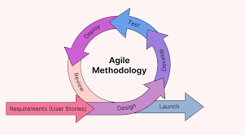

Figure 3.1: Illustration of Agile Methodology (Source: https://katharostechie.in/ )
Agile methodology emphasizes:
- Customer collaboration over contract negotiation
- Adapting to change above adherence to a rigid plan
- Working software over comprehensive documentation
- Individuals and interactions over processes and tools
Agile Development Phases
The project was divided into several sprints, each of which was focused on specific features and results. One of the key benefits of the sprint structure is continuous improvement, regular stakeholder feedback, and early issue identification.

Table 3.1: Agile Development Phases
Sprint | Focus | Deliverables
Sprint 1 | Project Setup & Foundation | Database schema, authentication system, basic UI framework
Sprint 2 | Core Features; Resources | Resource upload, categorization, download, and preview functionality
Sprint 3 | User Management & RBAC | Admin panel, user management, role and permission system
Sprint 4 | Announcements & Notifications | Announcement creation, publishing, notification system
Sprint 5 | Donations Integration | Paystack payment integration, donation tracking with CSV and pdf export
Sprint 6 | Calendar Events | Event creation, scheduling, public/private visibility
Sprint 7 | Live Meetings | Jitsi Meet integration, meeting creation, role-based access
Sprint 8 | Testing & Refinement | Bug fixes, performance optimization, security enhancements
Sprint 9 | Documentation & Deployment | User documentation, deployment scripts, final testing

Agile Risk Management
Risk management forms part of the agile development process. Risks that could arise were identified in advance and ways of mitigation developed early to counter them.

Table 3.2: Agile Risk Management
Risk Type | Risk | Mitigation (Agile Strategy)
Technical | Integration challenges with third-party APIs (Paystack, Jitsi) | Early prototyping in Sprint 1, continuous integration testing, fallback options identified
Technical | Database performance with large file uploads | Incremental testing with various file sizes, optimization in each sprint, file size limits (1GB)
Technical | Browser compatibility issues | Cross-browser testing throughout development, responsive design framework (Bootstrap 5)
Scope | Requirement changes during development | Regular stakeholder meetings, prioritized backlog, sprint reviews for scope adjustments
Security | Vulnerabilities in authentication and authorization | Security sprints, regular security audits and penetration testing in Sprint 8
Resource | Limited development time and resources | Focused sprint goals, scope approach, phased feature delivery
User Experience | Navigation is complicated; it confuses users. | Conducted usability testing, iterated on navigation design based on feedback.
Data | Loss and corruption of data | Strategies for database backup, redundancy of file storage, management of transactions

3.3.1 Method 1: Interviews
Structured interviews with key stakeholders, including executives at MSSN Baze, regular users of the platform, administrative staff, and IT personnel, were conducted to understand the current workflow and challenges that exist, and identify essential features and priorities. This also aimed to elicit the requirements for roles and permissions, identification of technical constraints, and an assessment of security and privacy concerns. The interviews highlighted important needs that included better organization and searching of Islamic and academic resources; the availability of a central, reliable system for announcements; clearly defined role-based access control; transparent donation tracking for accountability; event scheduling to be integrated, keeping members up to date; and video-meeting capability providing remote support for lectures and executives when physical gatherings are not possible.

3.3.2 Method 2: System Observation and Analysis
The observation and subsequent analysis of the system showed a number of gross inefficiencies in the operations of MSSN, including the disorganized distribution of resources via WhatsApp, email, and physical handouts; undependable communication via numerous WhatsApp groups, notice boards, and word of mouth; insecure, manual donation tracking without any central financial system; and ad hoc user management without a unified database or automated roles. Besides, the lack of a centralized repository for managing content, structured organization of resources, integrated event management system, transparent processing of financial transactions, and digital collaboration tools pointed to significant functional gaps, all of which directly influenced the design choices and feature prioritization for the new platform.

3.4 Tools and Techniques
The development of this platform required an integrated suite of tools and techniques from multiple categories, the choice of which was based on the requirements of the project, expertise within the team, scalability considerations, and budget.

Table 3.3: Development Tools and Techniques
Category | Technique/Tool Type | Description
Programming Language | JavaScript (Node.js) | The purpose is a server-side runtime environment that is used for building scalable network applications.
Web Framework | Express.js | Compact, expressive, and flexible Node.js web application framework that gives robust features
Template Engine | EJS (Embedded JavaScript) | A simple templating language to generate HTML markup with JavaScript
Database ORM | Sequelize | Promise-based Node.js ORM supporting MySQL, PostgreSQL and SQLite.
Database Systems | MySQL/SQLite/PostgreSQL | Relational database management systems which are used to store data
Authentication | Session-based Auth | Express-session for managing user sessions and authentication state
Security | bcryptjs, csurf, Helmet | Password hashing, CSRF protection, and HTTP security headers
File Upload | Multer | Middleware for multipart/form-data, primarily for file uploads.
Frontend Framework | Bootstrap 5 | CSS framework for responsive, mobile-first web design
Payment Integration | Paystack API | For processing online donations securely using a payment gateway.
Video Conferencing | Jitsi Meet | Free open-source video-conference solution (by meet.jit.si)
Prayer Times API | Aladhan API | Islamic prayer times calculation service based on location and calculation method
PDF Generation | PDFKit | Library to generate PDF documents including tables and formatting
Email Service | Nodemailer | Module to send emails (notifications & receipts)
Version Control | Git | It allows users to track modifications in their code
Development Environment | Nodemon | Utility for automatically restarting Node.js applications during development
Environment Management | Dotenv | Package for loading environment variables from .env file
Input Validation | express-validator | A set of Express.js middlewares that wraps validator.js to make it easy to validate request data.
HTTP Client | Axios | Promise-based HTTP client for making API requests (Paystack, Aladhan integration)

Developer's Specification

Table 3.4: Developer's Specification – Hardware
Component | Specification | Purpose
Processor | Intel Core i5 or equivalent (4+ cores) | Development and local testing
RAM | 8GB minimum, 16GB recommended | Running development server, database, and IDE simultaneously
Storage | 256GB SSD minimum | Fast access to project files and dependencies
Network | Broadband internet connection | Access to npm registry, GitHub, and deployment services
Display | 1920x1080 resolution minimum | Comfortable code viewing and debugging
Peripherals | Keyboard, Mouse | Navigation and failures

Table 3.5: Developer's Specification – Software
Category | Software | Version/Purpose
Operating System | Windows 10/11, macOS, or Linux | Latest stable version
Runtime Environment | Node.js | V15 or Higher
Package Manager | npm | v9.0.0 or higher
Version Control | Git | For maintaining, control, tracking and storing progress
Code Editor | VS Code | For code development
Web Browser | Chrome, Firefox, or Edge (latest) | Testing and debugging
MySQL Workbench | Version 15 | Database management and query testing
API Testing | Postman, Insomnia or Manual | For testing API endpoints

Client's Specification

Table 3.6: Client's Specification – Hardware
Component | Minimum Requirement | Recommended
Device | Desktop, laptop, tablet, or smartphone | Desktop or laptop for optimal experience
Processor | Any modern processor | Multi-core processor for better performance
RAM | 2GB | 4GB or more
Storage | 100MB free space | 500MB for cache and temporary files
Network | Stable internet connection (1 Mbps) | Broadband (5+ Mbps) for faster loading
Display | 1024x768 resolution | 1920x1080 or higher
Browser | Modern browser (Chrome, Firefox, Safari, Edge) | Latest version of any major browser
Camera | Required | For video meetings
Microphone | Required | For video meetings

Table 3.7: Client's Specification – Software
Software | Requirement | Notes
Operating System | Any modern OS | Windows, macOS, Linux, iOS, Android
Web Browser | Modern browser with JavaScript enabled | Chrome 90+, Firefox 88+, Safari 14+, Edge 90+
JavaScript | Must be enabled | Required for application functionality
Cookies | Must be enabled | Required for authentication
Internet Connection | Stable connection | Required for all operations

3.5 Ethical Considerations
Key ethical considerations that were addressed in the development of the Baze MSSN Repository Platform include strong user privacy through secure data storage, encrypted passwords, and user-controlled information; protection of content ownership through proper attribution and copyright compliance; clear, transparent donation handling with traceable transactions and certified payment processing; fair and nondiscriminatory role-based access control; adherence to security best practices by performing audits, hashing, CSRF protection, and responsible vulnerability disclosure; commitment to accessibility, WCAG-aligned, responsive, and keyboard-friendly design; and commitment to positive community impact, from content moderation through culturally respectful guidelines and features that support safe and productive engagement for all users.

3.6 Requirement Analysis
- User Needs Hierarchy
The analysis of requirements organizes user needs in a hierarchy: from most essential, like authentication, secure data storage, basic resource management, and announcements; to core functional needs, like resource categorization, role management, donation tracking, event scheduling, and notifications; to enhanced needs, which include resource previews, advanced search, bulk operations, email alerts, analytics, and video meetings; finally, the advanced future-oriented needs encompassing mobile support, offline access, expanded analytics, external integrations, multilingual capability, and automated backup and recovery.

- Shortcomings in Existing Systems
The major shortcomings of the prevailing manual and fragmented systems include disorganized and non-searchable resources with no central repository, no backups, or access control; unreliable communication channels where announcements get lost, are non-categorized, and offer no notifications or history; inefficient financial management with manual tracking, limited transparency, no automated receipts, and no payment integration; poor user management where there is no unified database, roles are inconsistently assigned, there is no password recovery, and no tracking of activities; and ineffective event management due to the absence of a single calendar, reminders, RSVP features, or integration with associated resources.

- Institutional Requirements
The platform needs to adhere to the hierarchical structure of MSSN with multi-level permission, follow data protection and financial regulations, and be audited. It should leverage systems already in place like email notification, Paystack for payment processing, manual verification of bank transfers, Jitsi Meet for video conferencing, and Aladhan API for prayer times, while supporting the export of data in CSV and PDF format. In addition, it needs to scale up for membership growth, resource upsurge, and usage spikes while remaining easy to maintain through regular backups, clear documentation, and simplified updates.

- Technical Limitations
The project is framed by the limited budget and infrastructural resources for cloud hosting, free or open-source tools, and a fully web-based browser-dependent design. Security best practices shall be followed within the bounds of the available tools, ensuring that data is encrypted and transmitted securely. Development constraints further include workflow by a solo developer, manual testing involved, and stringent timelines, with service-specific limitations where the Paystack API has rate limits, while Jitsi Meet depends on public instances for meetings, and SMTP has general email delivery limitations.

3.7 Requirements Specifications
In this section, detailed specification of both the functional and non-functional requirements of the system is provided.

3.7.1 Functional Requirement Specifications
The functional requirements define what the system is supposed to do-the features, functions that are available for use by the users.

Table 3.8: Functional Requirements
ID | Requirements | Description
FR1 | User Authentication | System shall permit users to register, login, and log out. Passwords shall be encrypted using bcrypt. Users shall be allowed to reset forgotten password via email.
FR2 | Role-Based Access Control | System shall support multiple user roles that may be assigned to users, along with specific access permissions to modules as per the requirement. Admin can assign Roles and permissions to a particular user.
FR3 | Resource Management | The system shall be capable of allowing authorized users to upload resources of up to 1 GB in PDF, audio, and video formats.
FR4 | Resource Editing | System shall allow admins and executives to edit resource details: title, description, category, and replace uploaded files.
FR5 | Announcement System | The system should provide a facility to create, edit, publish, and delete announcements by the administrator or any executive.
FR6 | Notification System | System shall display notifications for new announcements, resource uploads, and other important events. Users can mark notifications as read and view notification history.
FR7 | Donation Processing | System shall integrate with Paystack API in processing online donations. System shall also support direct bank transfer donations that need to be manually verified.
FR8 | Calendar Events | System will allow admin and executives to create calendar events, which can include title, description, date and time, location, and type of event. Events shall be public or private. Users can see upcoming events.
FR9 | Live Meetings | The system shall integrate with Jitsi Meet for video and voice meetings. The administrators/executives can create a meeting with role-based access control, while the user can join the meeting as per their role.
FR10 | User Management | The administrator should be allowed to create, edit, delete, and view user accounts. Administrators are able to reset the password for the users and change the user role.
FR11 | Dashboard | The system should provide an admin dashboard with statistics about total users, resources, donations, announcements. It should show recent activities on the dashboard and provide easy access to common tasks.
FR12 | Analysis and Statistics | System should present administrators with a detail analysis page displaying in-depth user statistics: total users, superusers, admins, executives, members, recent users.
FR13 | Profile Management | Users can access their profile information, assigned roles, and update their passwords. Users can view their activity history.
FR14 | Search and Filter | System shall allow the user to search for resources by title, description, or category. Users can filter resources by category and file type.
FR15 | In-Browser Preview of Files | System shall allow the user to preview PDF without downloading it. The preview shall support zooming, navigation, and download options.
FR16 | Data Export | Administrators shall be able to export donation records to CSV and PDF formats.
FR17 | Prayer Times | System shall display daily prayer times along with Adhan and Iqama times.

3.7.2 Non-Functional Requirement Specifications
Non-functional requirements discussed how the system should be able to perform, and accomplish tasks.

Table 3.9: Non-functional Requirements
ID | Requirements | Description
NFR1 | Performance | Pages should take no longer than 3 seconds to load under normal conditions. File uploads should support files of 1 GB in size. Database queries should take no longer than 500ms for standard queries.
NFR2 | Scalability | The system should support up to 500 concurrent users. An efficient mechanism in file storage should support the growing list of resources.
NFR3 | Security | The system must enforce CSRF protection, password hashing using bcrypt, session management, input validation, and SQL injection protection. Sensitive data must be encrypted in transit using HTTPS and stored.
NFR4 | Reliability | The system shall remain highly available, handle errors gracefully with clear messages, and ensure data integrity in all database transactions.
NFR5 | Usability | The system should have a user-friendly interface with contemporary web design.
NFR6 | Accessibility | The System will comply with Level A guidelines of WCAG 2.1. The interface will support keyboard navigation. Images will provide text alternatives.
NFR7 | Browser Compatibility | System shall be able to support contemporary web browsers like Chrome 90+, Firefox 88+, Safari 14+, Edge 90+.
NFR8 | Portability | he system needs to be able to be deployed on different hosting platforms such as shared hosting, VPS, and cloud.
NFR9 | Maintainability | The code should comply with proper coding practices. The system design should make it easy to maintain and enhance. Migration of databases should be version-controlled.
NFR10 | Backup and Recovery | The system must support automated backups of databases. The administration team must be able to use backups for data restoration. User uploads must be backed up.

3.8 System Design
This section of the document elaborates on the system design pertaining to architecture, use cases, data models, and design diagrams.

3.8.1 Application Architecture
The Baze MSSN Repository Platform adopts a Model-View-Controller (MVC) design pattern modified for a web application:
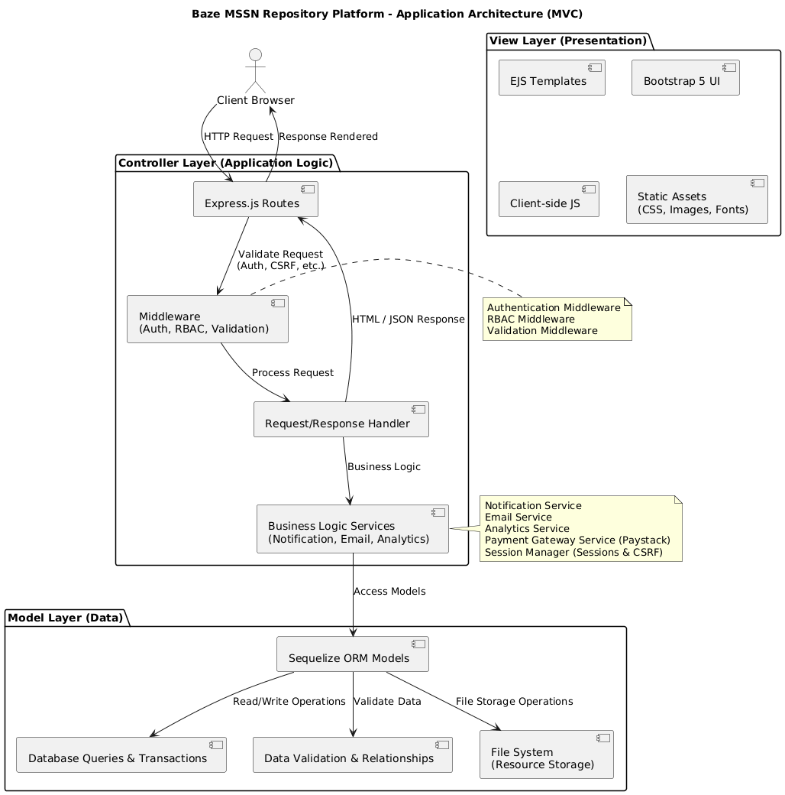

Figure 3.2: Application Architecture

3.8.2 Use Case

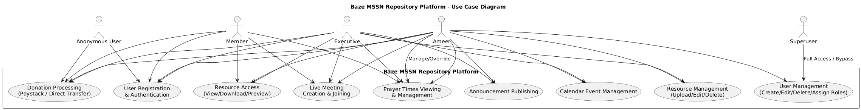

Figure 3.3: Usecase

3.8.3 Data Design
The database schema is designed using a relational model with normalized tables to ensure data integrity and minimize redundancy.

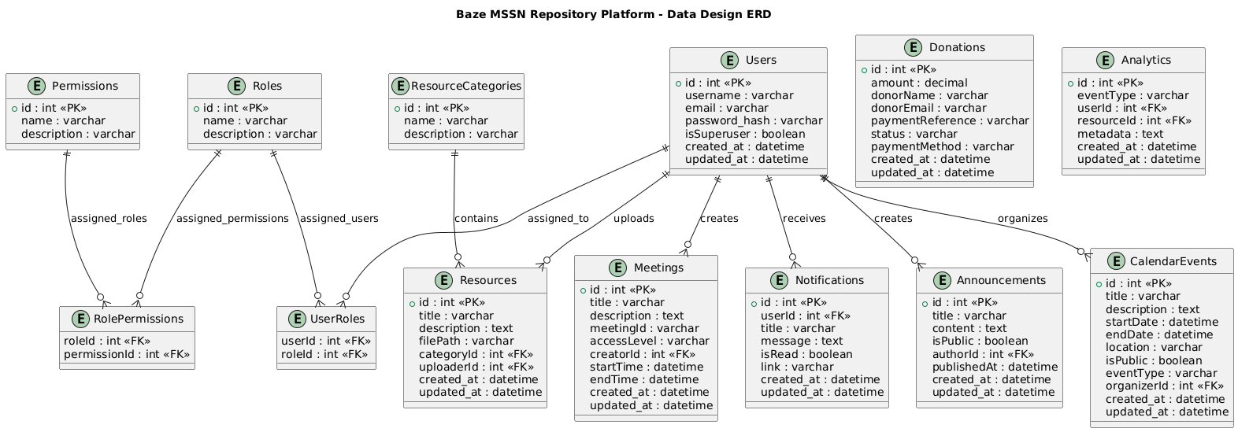

Figure 3.3: Data Design

3.8.4 Activity Diagrams
Activity diagrams illustrate the flow of activities in the system. Key processes include:
Resource Upload Activity:
1. User navigates to upload page
2. System checks authentication and permissions
3. User selects file and fills form
4. System validates file (size, type, required fields)
5. File is uploaded to storage
6. Database record created
7. Success message displayed
8. User redirected to resource list

Figure 3.4: Resource Upload Activity
Donation Processing Activity:
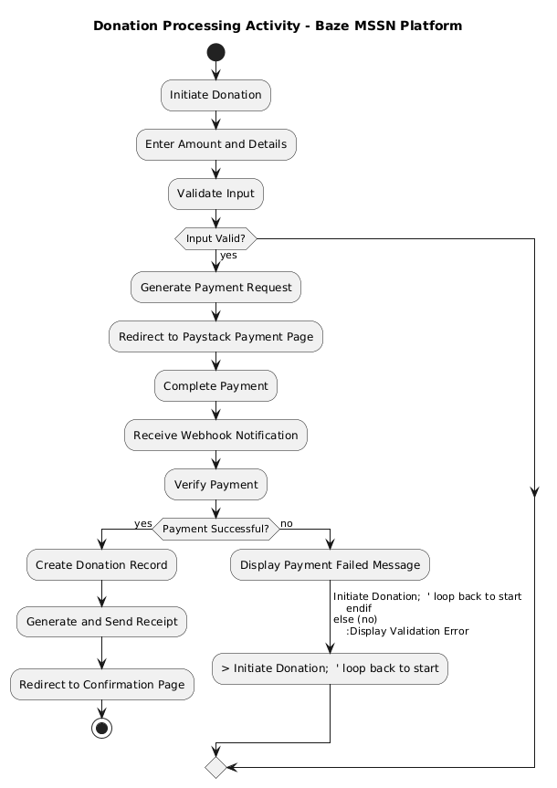

Figure 3.5: Donation Processing Activity

Announcement Publishing Activity:
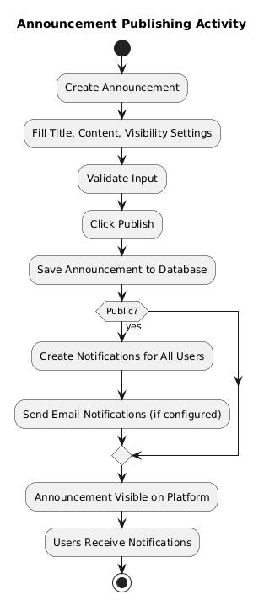

Figure 3.6: Announcement Publishing Activity

3.8.5 Dataflow Diagram
The dataflow diagram shows how data moves through the system:
Level 0 (Context Diagram):
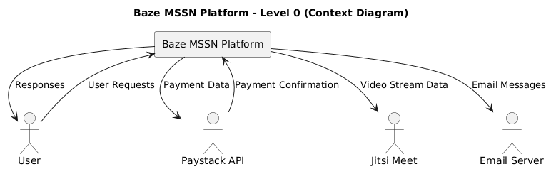

Figure 3.7: Dataflow Diagram - Level 0
Level 1 (System Overview):
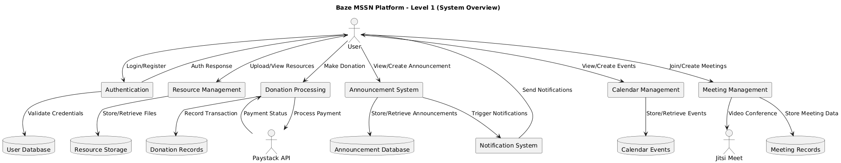

Figure 3.8: Dataflow Diagram - Level 1

3.8.6 Control Flow Diagram
Control flow diagrams illustrate the sequence of operations and decision points:

Authentication Flow:
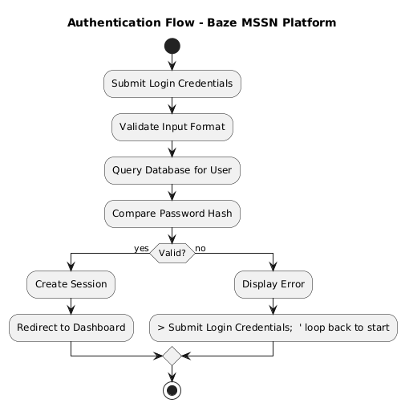

Figure 3.9: Authentication Flow

3.8.7 Entity-Relationship Diagram (ERD)
The ERD visualizes database entities and their relationships:

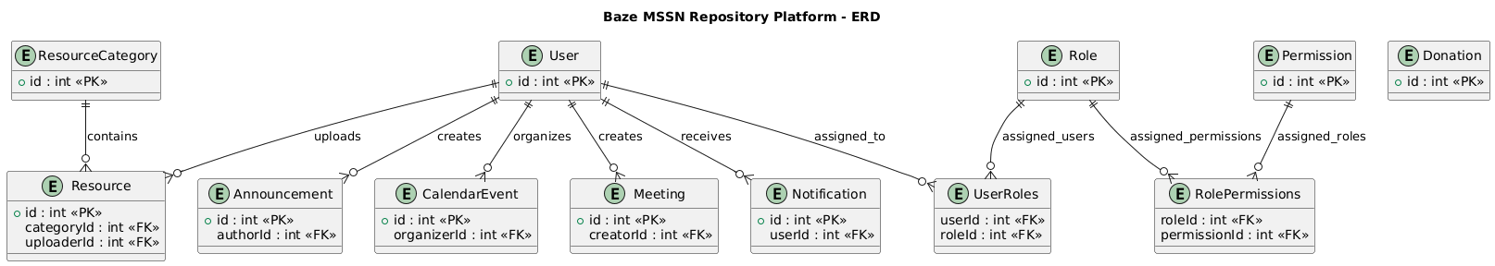

Figure 3.10: Entity Relationship Diagram

3.8.8 User Interface Design
The UI design follows modern web design principles focusing on usability, accessibility, and aesthetics:

Figure 3.11: Home

Figure 3.12: Nav Bar
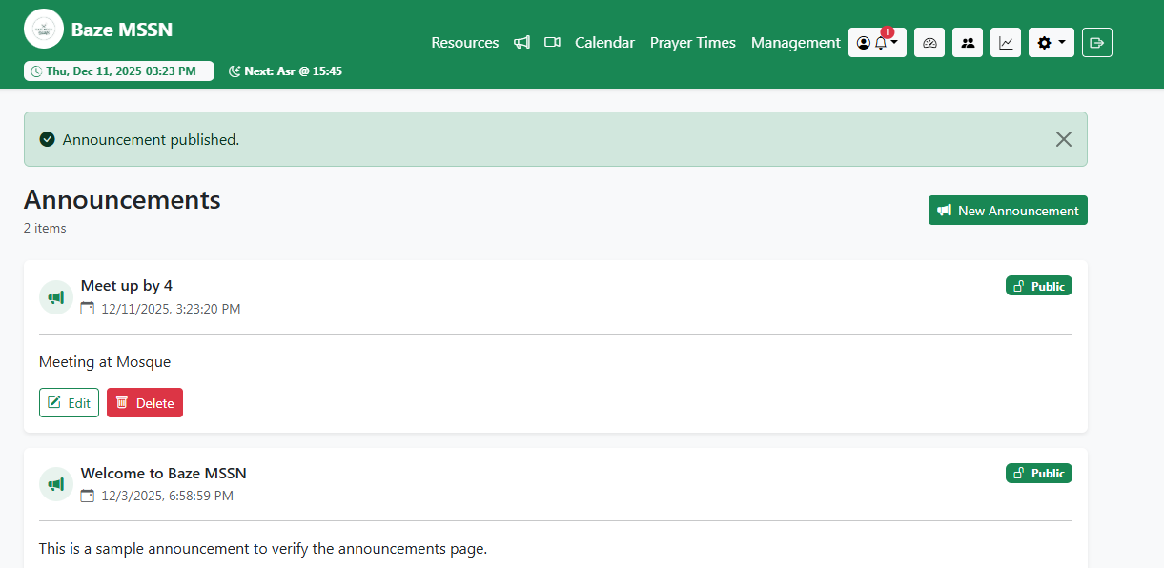

Figure 3.13: Announcement

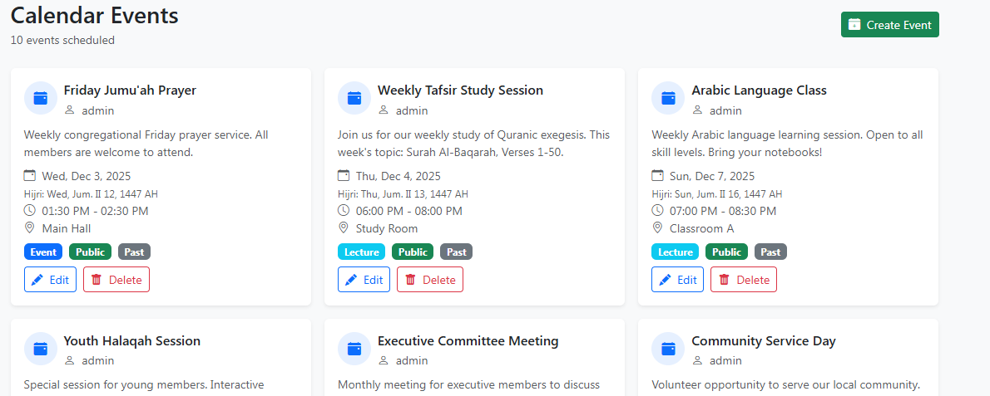
Figure 3.14: Calendar Events
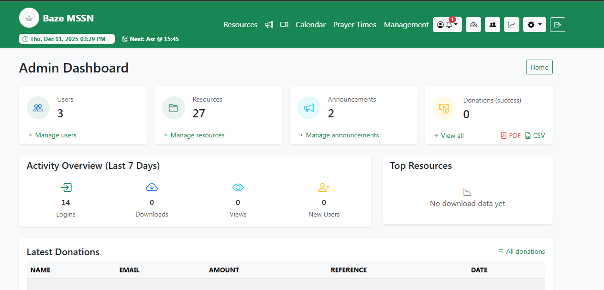

Figure 3.15: Admin Dashboard
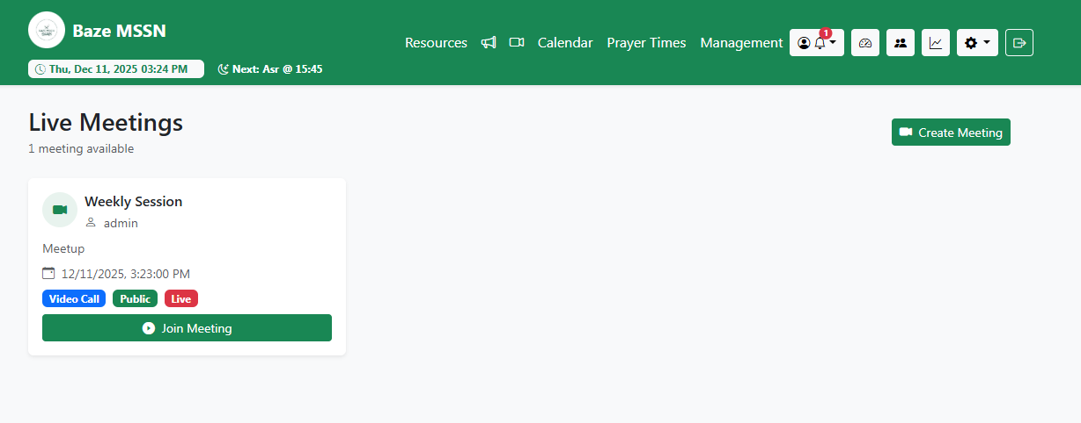

Figure 3.16: Calendar Event
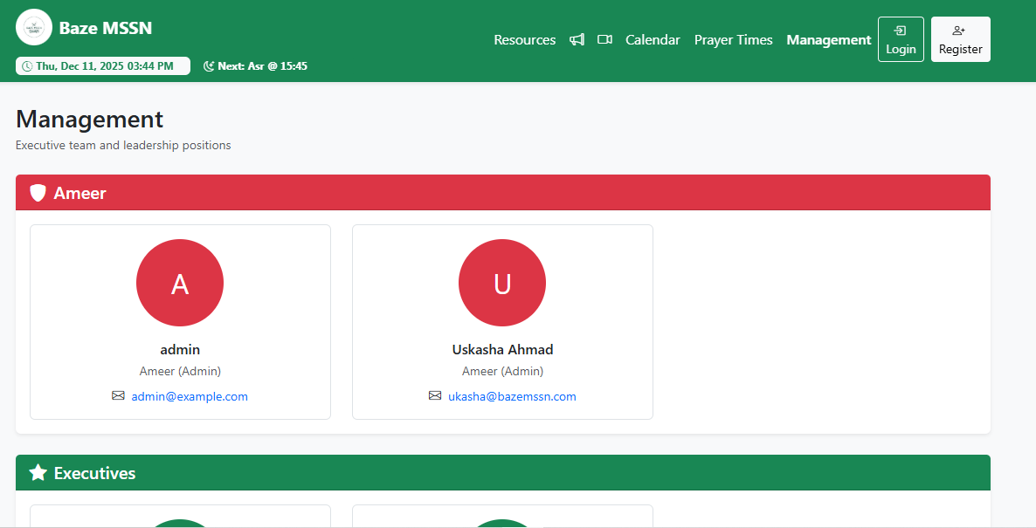

Figure 3.17: Management
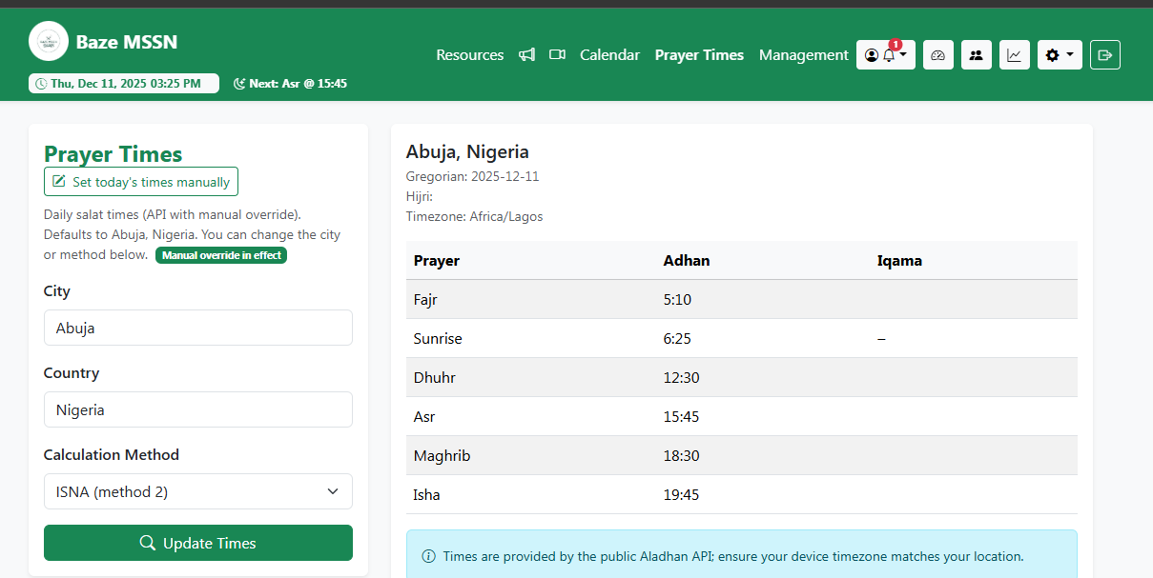

Figure 3.18: Prayer Times

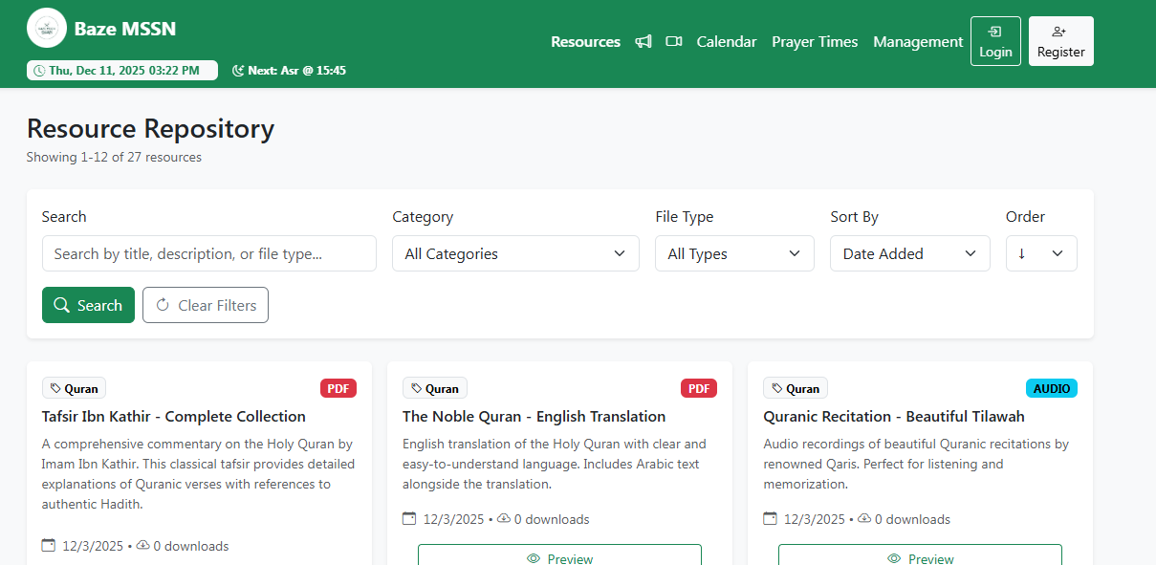

Figure 3.19: Resource Repository
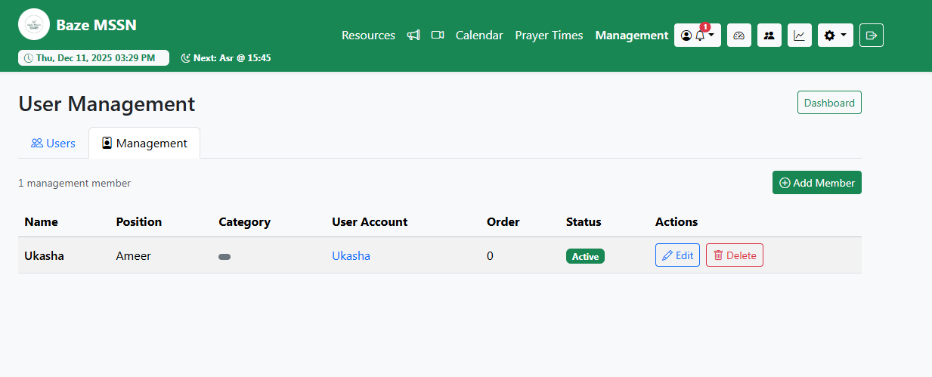

Figure 3.20: Users Managment

3.9 Summary
This chapter has offered a complete discussion on requirements analysis and system design for Baze MSSN Repository Platform with an emphasis on an agile and iterative approach with a flexible mindset. This discussion has emphasized key needs that were identified from interviews with users as well as observations of a system, an emphasis on a scalable model view controller design, and functional as well as non-functional needs. These needs, as discussed, are important for performance, security, and ease of use, with a discussion on ethical approaches that involve privacy, security, and community effects as well.

